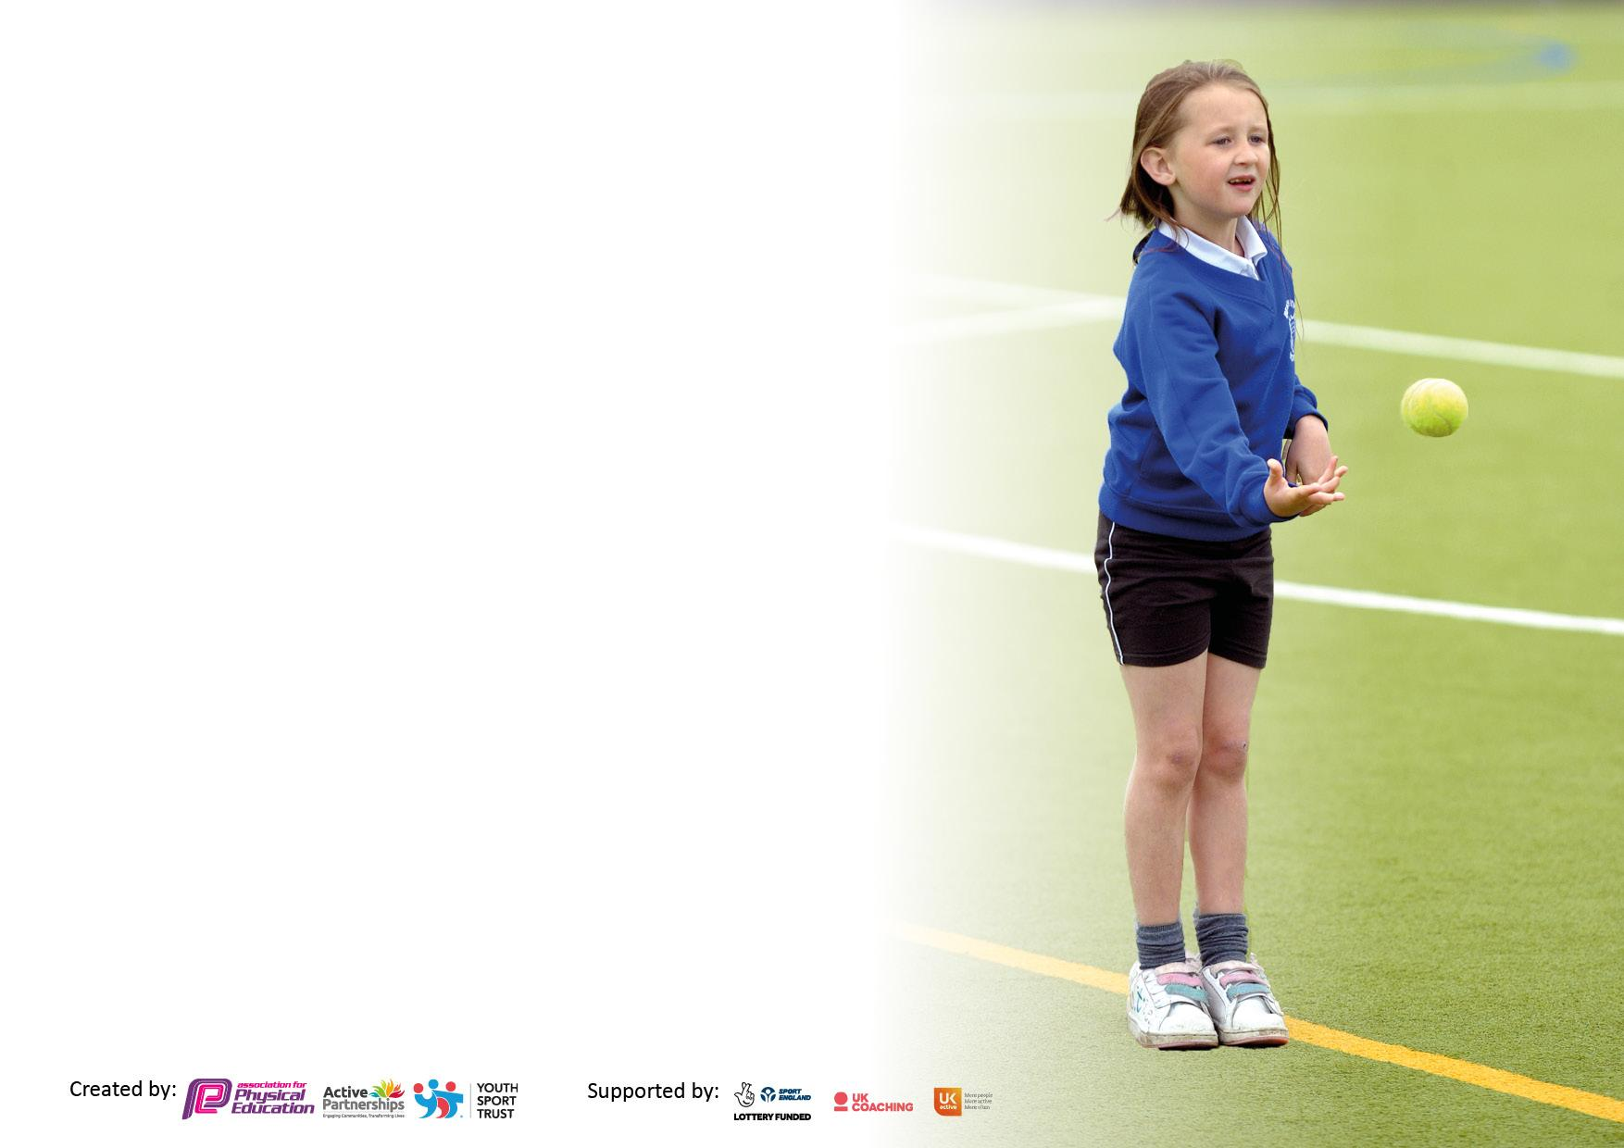

It is important that your grant is used effectively and based on school need. The Education Inspection Framework makes clear there will be a focus on **‘whether leaders and those responsible for governors all understand their respective roles and perform these in a way that enhances the effectiveness of the school’**.

Under the Quality of Education Ofsted inspectors consider:

**Intent** - Curriculum design, coverage and appropriateness

**Implementation** - Curriculum delivery, Teaching (pedagogy) and Assessment

**Impact** - Attainment and progress

To assist schools with common transferable language this template has been developed to utilise the same three headings which should make your plans easily transferable between working documents.

Schools must use the funding to make **additional and sustainable** improvements to the quality of Physical Education, School Sport and Physical Activity (PESSPA) they offer. This means that you should use the Primary PE and sport premium to:

* Develop or add to the PESSPA activities that your school already offer
* Build capacity and capability within the school to ensure that improvements made now will benefit pupils joining the school in future years
* The Primary PE and sport premium should not be used to fund capital spend projects; the school’s budget should fund these.

Pleasevisitgov.ukfortherevisedDfEguidanceincludingthe5keyindicatorsacrosswhichschoolsshoulddemonstrate animprovement.Thisdocumentwillhelpyoutoreviewyourprovisionandtoreportyourspend.DfEencouragesschools to use this template as an effective way of meeting the reporting requirements of the Primary PE and Sport Premium.

We recommend you start by reflecting on the impact of current provision and reviewing the previous spend.

Schools are required to publish details of how they spend this funding, including any under-spend from 2021/2022, as well as on the impact it has on pupils’ PE and sport participation and attainment. **All funding must be spent by 31st July 2023.**

We recommend regularly updating the table and publishing it on your website throughout the year. This evidences your ongoing self-evaluation of how you are using the funding to secure maximum, sustainable impact. Final copy must be posted on your website by the end of the academic year and no later than the 31st July 2023. To see an example of how to complete the table please click HERE.



|  |  |
| --- | --- |
| Total amount carried over from 2022/23 | £0 |
| Total amount allocated for 2022/23 | £20,000 |
| How much (if any) do you intend to carry over from this total fund into 2023/24? | £0 |
| Total amount allocated for 2023/24 | £16,000, plus £10 per pupil (400-450) |
| Total amount of funding for 2023/24. To be spent and reported on by 31st July 2024. | £20,000-£20,500 |



|  |  |
| --- | --- |
| Meeting national curriculum requirements for swimming and water safety.  N.B. Complete this section to your best ability. For example you might have practised safe self-rescue techniques on dry land which you can then transfer to the pool when school swimming restarts.  **Due to exceptional circumstances priority should be given to ensuring that pupils can perform safe self rescue even if they do not fully meet the first two requirements of the NC programme of study** |  |
| What percentage of your current Year 6 cohort swim competently, confidently and proficiently over a distance of at least 25 metres?  **N.B.** Even though your pupils may swim in another year please report on their attainment on leaving primary school at the end of the summer term 2024.  Please see note above | 60% |
| What percentage of your current Year 6 cohort use a range of strokes effectively [for example, front crawl, backstroke and breaststroke]?  Please see note above | 50% |
| **What percentage of your current Year 6 cohort perform safe self-rescue in different water-based situations?** |  |
| Schools can choose to use the Primary PE and sport premium to provide additional provision for swimming but this must be for activity **over and above** the national curriculum requirements. Have you used it in this way? | No |



|  |  |  |  |  |
| --- | --- | --- | --- | --- |
| **Academic Year:** 2023/24 | **Total fund allocated:** | **Date Updated:** | |  |
| **Key indicator 1:** The engagement of all pupils in regular physical activity – Chief Medical Officers guidelines recommend that primary school pupils undertake at least 30 minutes of physical activity a day in school | | | | Percentage of total allocation: |
| 58% |
| **Intent** | **Implementation** | | **Impact** |  |
| Your school focus should be clear what you want the pupils to know and be able to do and about  what they need to learn and to  consolidate through practice: | Make sure your actions to achieve are linked to your intentions: | Funding allocated: | Evidence of impact: what do pupils now know and what can they now do? What has changed?: | Sustainability and suggested next steps: |
| To utilize expert coaches to supplement existing PE curriculum,  Increasing staff’s knowledge and understanding of skills and techniques. | Nathan Thompson to work with Teaching assistants to teach PE with KS2 children. | £~10,000? | Children in KS2 benefitting from specialist coaching, with children having better knowledge of terms and processes. TA’s also benefit from being able to watch the coach in action rather than just a written explanation. | Teaching Assistants to continue to work closely with NT to ensure they are comfortable teaching lessons in his absence. |
| Walk to school badges to promote a healthy lifestyle. | Funding for badges has been withdrawn, so badges now need to be paid for. School to pay for a percentage of children from KS1 and Reception to receive badges if they walk to school at least twice a week. | £420 | Use of walk to school data to show how many children have walked to school across years, hopefully seeing an upward trend, something they will hopefully continue as they move up into KS2. |  |
| New lines on school yard to promote children’s imagination to play. | Lines with games and activities have worn off and need repainting. | £1000 | To add activities to the yards for children to use during break times, which is of extra importance in the Infant yard where the size of the yard restricts children using a lot of equipment in the small space. |  |
| Staff to put on extra curricular clubs throughout the year for children throughout school. | Clubs including mini football league for years 3 and 4, Gym club for year 1 and 2. Netball club for 5 and 6.  Funding available to equipment and resources required to support clubs. (Mini football league requires mini goals, new wooden bench, sports pump and mini balls.) | up to £500 | All children have access to at least one club throughout the year. |  |
| **Key indicator 2:** The profile of PESSPA being raised across the school as a tool for whole school improvement | | | | Percentage of total allocation: |
| 22% |
| **Intent** | **Implementation** | | **Impact** |  |
| Your school focus should be clear what you want the pupils to know and be able to do and about  what they need to learn and to  consolidate through practice: | Make sure your actions to achieve are linked to your intentions: | Funding allocated: | Evidence of impact: what do pupils now know and what can they now do? What has changed?: | Sustainability and suggested next steps: |
| To subscribe to the School Sports Network. | Using the School Sports Network for-  PE coordinator CPD, including regular termly update meetings, courses on ofsted as well as support when completing School Games Mark Award.  Participation in inter school events, including mixed team football, girls football, as well as class events during school hours.  Free coaching hours to be used in school to support staff teaching (Reception).  Support hiring extracurricular coaches. | £2820 | Coordinator is aware of current issues, as well as being supported for wider school pressures including ofsted.  Children's confidence in tackling new opponents has improved due to the interschool nature of football events. | Continue using Sports Network links for continued access to CPD, specialist coaching and both competitive and non-competitive events in a large choice of sports. |
| New Kits for sports teams representing school. | After changing from Ashley Primary to Ashley Academy, the school continues to use old kits with the old badge on. To help promote our new identity, the school should purchase new kits for both mixed and girls football teams, as well as an additional kit to be used for other teams (Rugby etc.) | £200 per kit x3 £600 |  |  |
| New equipment for PE curriculum.  To improve children’s daily activity, as well as improving behaviour on the yard by giving more options for children to do. | After moving equipment into a larger sports cupboard, it allowed easier audit of resources. As a result we have certain resources that are missing or need supplementing for certain curriculum areas.  15x Basketballs, 10x Gym mats, 4x tumbling mats, 1x ball pump, 30x netballs, 1x bucket tennis balls, 2x netball ball hoops, 1x set rounders bases.  To discuss with children what kind of things they would like to do at playtimes, then purchasing new equipment for children to enjoy. | up to £1000 |  |  |

|  |  |  |  |  |
| --- | --- | --- | --- | --- |
| **Key indicator 3:** Increased confidence, knowledge and skills of all staff in teaching PE and sport | | | | Percentage of total allocation: |
| 3% |
| **Intent** | **Implementation** | | **Impact** |  |
| Your school focus should be clear | Make sure your actions to | Funding | Evidence of impact: what do | Sustainability and suggested |
| what you want the pupils to know | achieve are linked to your | allocated: | pupils now know and what | next steps: |
| and be able to do and about | intentions: |  | can they now do? What has |  |
| what they need to learn and to |  |  | changed?: |  |
| consolidate through practice: |  |  |  |  |
| PE coordinator to improve knowledge and understanding of the role through CPD. | PE coordinator to attend Sports Network events throughout the school year, with supply cost covered through Premium fund | Rate of supply cover (£150 per day?) up to 4 days. | Coordinator to implement ideas within school, sharing ideas with school leaders as well as teaching and support staff. |  |
| To improve staff confidence across all areas of PE. | To develop staff knowledge via either in person and/or online courses. | £TBC | Staff will feel more confident teaching lessons. |  |
| **Key indicator 4:** Broader experience of a range of sports and activities offered to all pupils | | | | Percentage of total allocation: |
| 19% |
| **Intent** | **Implementation** | | **Impact** |  |
| Your school focus should be clear | Make sure your actions to | Funding | Evidence of impact: what do | Sustainability and suggested |
| what you want the pupils to know | achieve are linked to your | allocated: | pupils now know and what | next steps: |
| and be able to do and about | intentions: |  | can they now do? What has |  |
| what they need to learn and to |  |  | changed?: |  |
| consolidate through practice: |  |  |  |  |
| To continue to provide extracurricular clubs which present children with opportunities to take part in activities that differ from traditional PE curriculum. | Nathan Thompson to run Rugby and Girls Football after school clubs.  Judo from Patrick Tucker. | NT £1,800  Judo £1800 | School to fulfill its community role by offering clubs before and after school. Increased physical activity for children involved.  Increased confidence for children, having that feeling of being part of a club or team. |  |

|  |  |  |  |  |
| --- | --- | --- | --- | --- |
| **Key indicator 5:** Increased participation in competitive sport | | | | Percentage of total allocation: |
| % |
| **Intent** | **Implementation** | | **Impact** |  |
| Your school focus should be clear | Make sure your actions to | Funding | Evidence of impact: what do | Sustainability and suggested |
| what you want the pupils to know | achieve are linked to your | allocated: | pupils now know and what | next steps: |
| and be able to do and about | intentions: |  | can they now do? What has |  |
| what they need to learn and to |  |  | changed?: |  |
| consolidate through practice: |  |  |  |  |
| To increase the number of children participating in group sporting events through increasing access to events around region.  Focus on Year groups attending at least one event throughout year. | Children to attend sporting events using mini bus for travel.  Girls football events through Sports Network.  Girls football event with Sunderland WISE schools.  Friendly Rugby and football matches with Holy Trinity. | Mini Bus petrol across year up to £300. | Small teams are easily able to attend events, games and tournaments due to the lack of having to outsource expensive coaches. |  |

|  |  |
| --- | --- |
| Signed off by | |
| Head Teacher: | Denise Todd |
| Date: | 2/10/2023 |
| Subject Leader: | Andrew Milner |
| Date: | 2/10/2023 |
| Governor: |  |
| Date: |  |